1. WIN + PAUSE

This keyboard combination brings up the system properties window. As you can see that computer uses WINDOWS 10. The manufacturer, model, CPU, RAM, system type etc. are also displayed.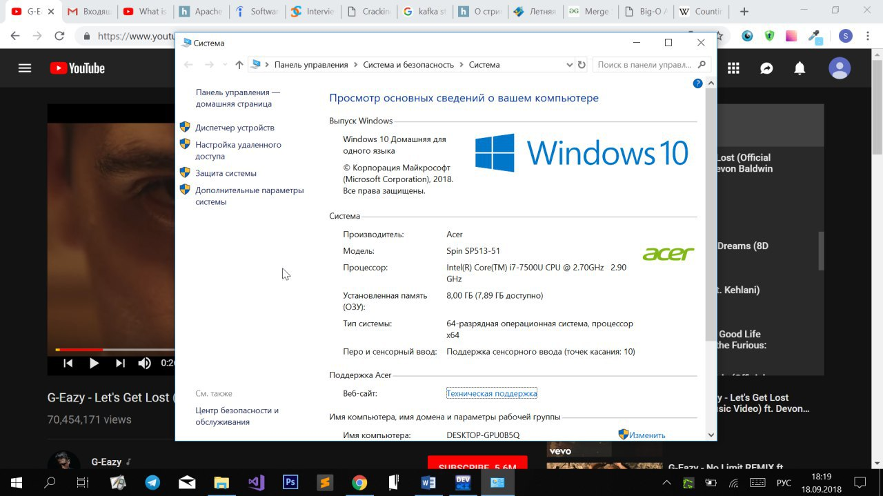

2. Win+R

Clicking opens the Run dialog box, in which you can type commands and get access to some options of the operating system.

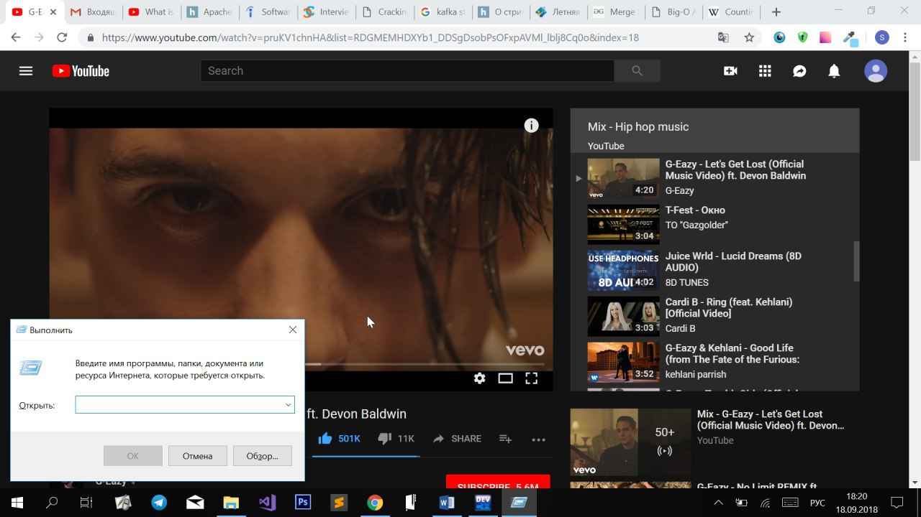

3. DxDiag

This command shows all the technical information about the computer: the model of the video card, the amount of memory on the hard drive, the operating system version, the type and frequency of the processor, the amount of RAM, etc.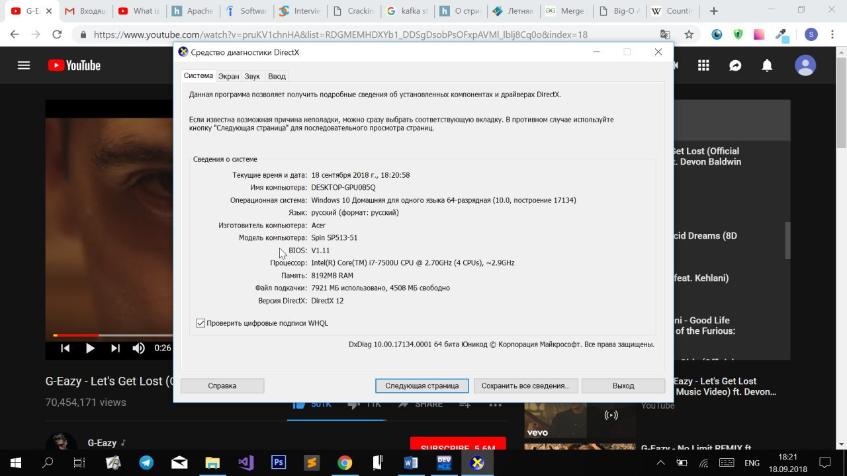

4. Win+E

This commend opens opens the quick access toolbar, which displays the most visited folders (up to twenty) and recently opened files (up to twenty).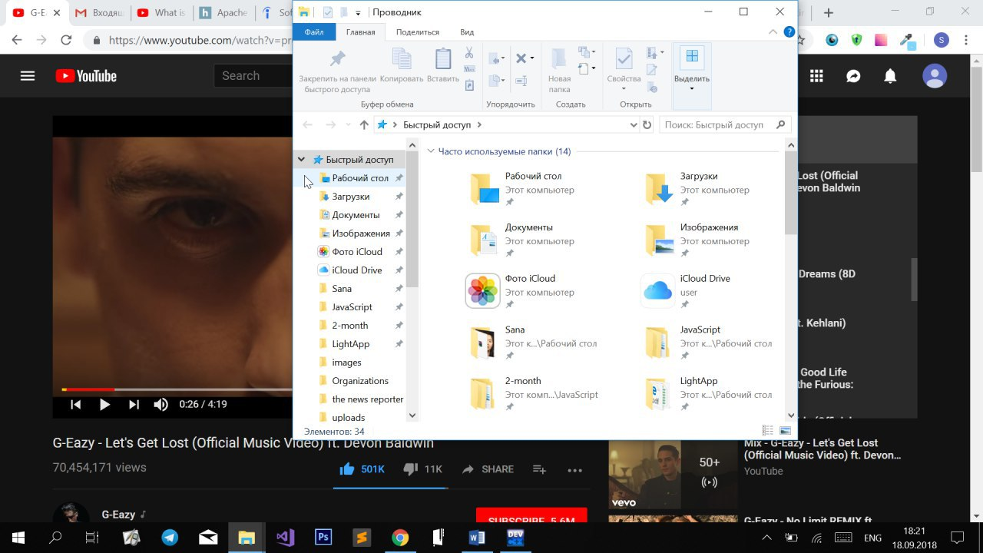

5. Win+E and ALT+ENTER

After selecting one folder and pressing ALT+ENTER computer shows all properties of particular folder: type, memory taken, location.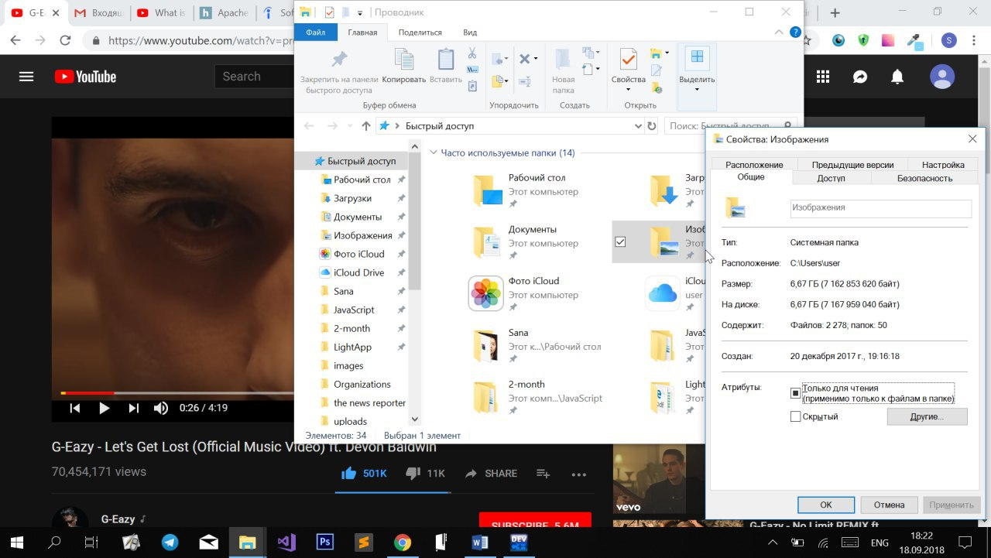

6. devmgmt.msc

By running this command in Run dialog box we can get access to to view and control the hardware attached to the computer. 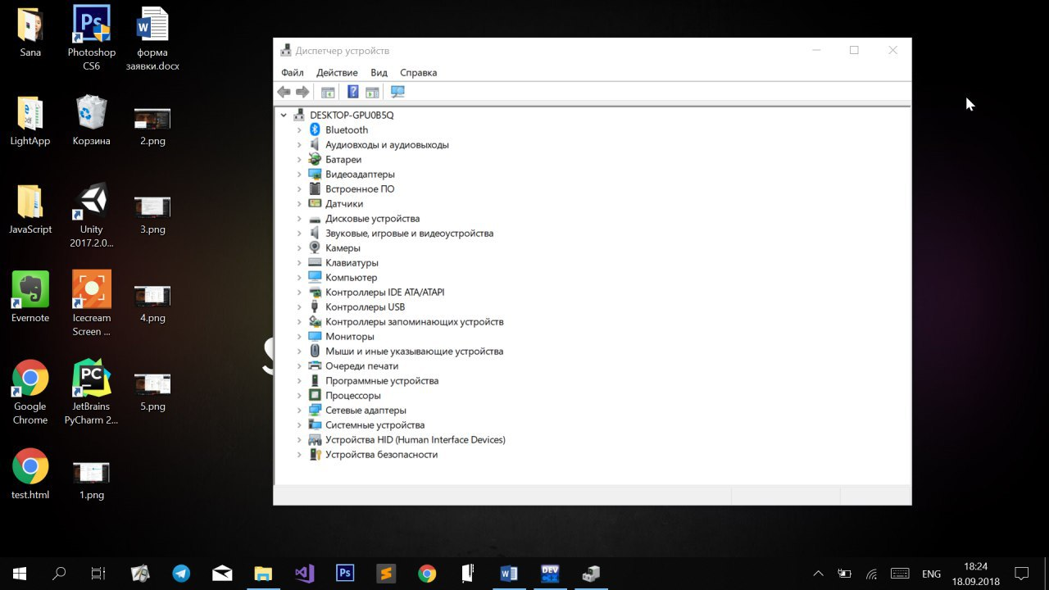

7. diskmgmt.msc

This is a Disk management command. By using it we can get access to all the disks used/ attached to the computer.